Christmas Crocheting: Handmade Holiday Gifts for your loved ones
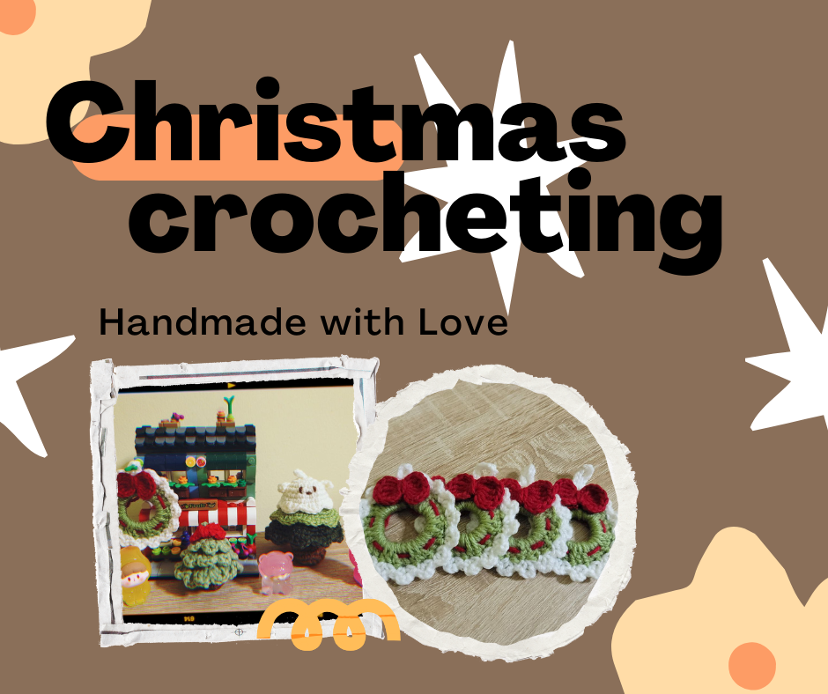
Christmas is coming, and it is now the perfect time to prepare a gift for your loved ones. If you are not sure about what to get, crocheting can be considered a wonderful way to add a personal touch to your holiday presents. From festive decorations to heartfelt gifts, Christmas-themed crochet projects are a creative and meaningful way to celebrate.
If you are an absolute beginner, you might want to check out some of the instruction videos below and practice the stitches first. Once you master the stitches, you can start to crochet anything you with patterns.
- How to make a Chain, Single crochet stitch and to weave at the end
https://www.youtube.com/watch?v=aAxGTnVNJiE&t=75s&ab_channel=simplydaisy
- How to make a Half double crochet, Double crochet and Triple crochet stitch
https://www.youtube.com/watch?v=jBj6MyMu9pU&ab_channel=simplydaisy
- How to make a Magic ring
https://www.youtube.com/watch?v=p298HxgsO1s&ab_channel=MJCarlos
Crochet Abbreviations
When reading a pattern or watching a tutorial video on the Internet, you might come across some abbreviations. It is better to know the meaning behind these abbreviations when you practice crocheting. Below are some common abbreviations you will see in patterns:
Ch – Chain
Sl st – Slip Stitch
Mr – Magic ring
Sc – Single Crochet
Hdc – Half Double Crochet
Dc – Double Crochet
Tr – Triple Crochet
Inc – Increase (Add one or more stitches)
Dec – Decrease (Eliminate one or more stitches)

Now to prepare to make some Christmas Decorations
To make Christmas crochet projects, gather:
- Red, green, white, and brown yarn: Traditional holiday colors set the festive tone.
- Crochet hooks: Match the size to your yarn’s thickness for smooth stitching.
- Decoration charms: Bells, buttons, or stars that can add charm to your projects.

Easy Projects for the Holidays
- Christmas Wreath:

You can try making different types of Christmasy Wreath with the tutorials below:

https://www.youtube.com/watch?v=mlZlOSmydWY&ab_channel=VickyHandmade

https://www.youtube.com/watch?v=IQH5ioFbLT8&ab_channel=XuxuCrochet
- Christmas Holly Leaf:

https://www.youtube.com/watch?v=ZqH_l3QwocY
- Christmas Tree:

https://www.youtube.com/watch?v=3nRVdoxLVl4&ab_channel=M%E1%BB%99cMi%C3%AAnCrochet

https://www.youtube.com/watch?v=H8c_asFILdg&ab_channel=KaneCrochet

https://www.youtube.com/watch?v=3mjHFaEk4vk&ab_channel=chanchan.crochet

Add a Personal Touch
Personalize your creations with embroidered names or initials. You can also experiment with fuzzy or sparkly yarn for an extra festive flair.
Crocheting for Christmas not only fills your home with warmth and creativity but also makes for thoughtful, handmade gifts your loved ones will cherish. You can also join the Student Life Team’s Knitting/Crocheting sessions. All materials are provided but you can also bring your own materials if you want to.
Grab your hooks and yarn, and let the holiday crafting begin!

