**How to update your address on the personal details page:**

**Option 1:**

1. Click Enter Address Manually – on the right-hand side

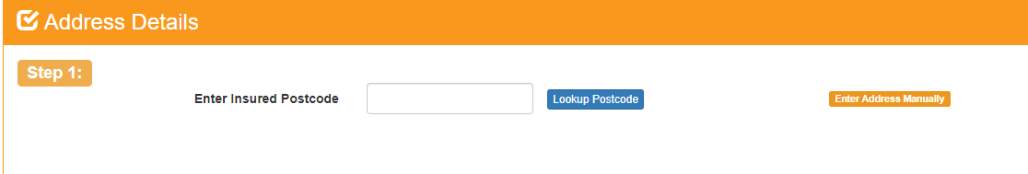

1. It will then produce blank address where you can manually type in your address

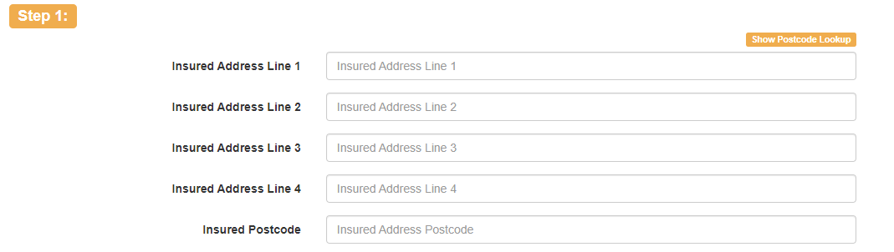

**Option 2:**

1. Enter your postcode and click the Lookup Postcode button 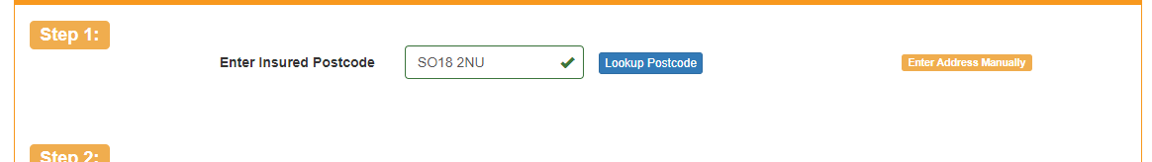
2. Then select the nearest address to the one you are looking for:

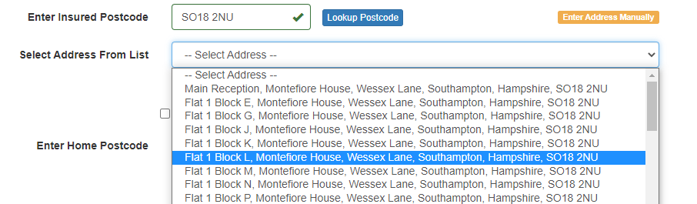

1. Once selected you will be able to click into each line of the address and update it accordingly

