Knitting a Scarf: A Cozy DIY for Beginners

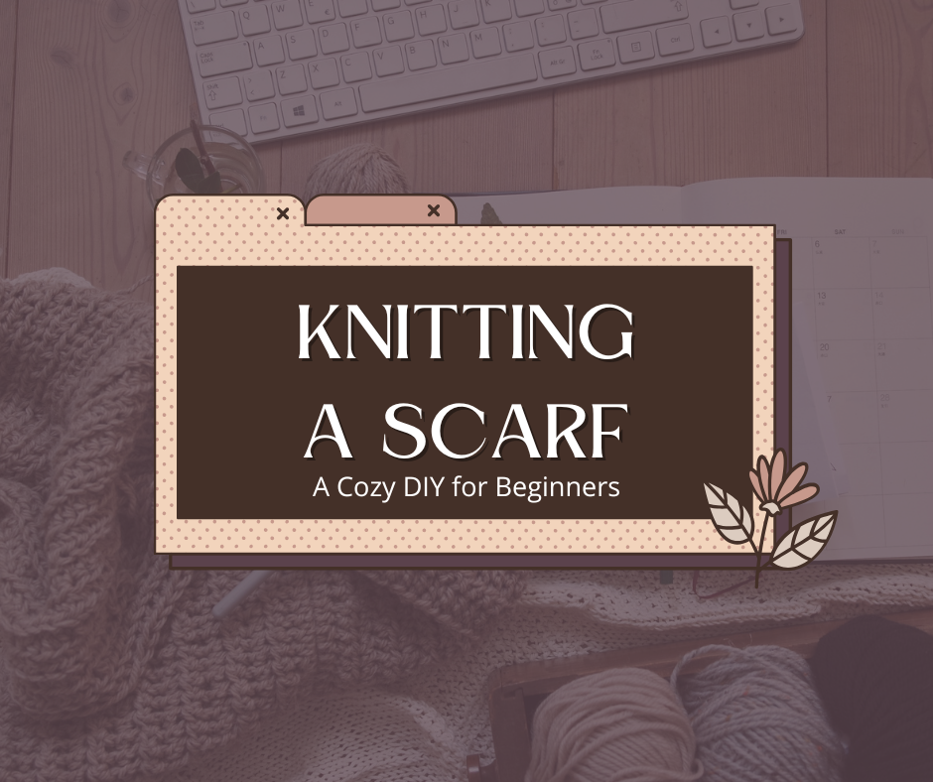

In the previous article, we looked at basic steps for Crocheting. Like Crocheting, Knitting is also quite easy if you know where to start and how to practice it on your own. Knitting a scarf is the perfect project for anyone looking to explore the world of yarn crafts. It’s simple, rewarding, and versatile—ideal for both beginners and seasoned knitters.

Again, if you are a beginner, it is recommended that you learn the stitches before starting with the patterns. Below are a few tutorial videos for you to start with:
- How to make a Slip knot, to cast on and to start knitting:
https://www.youtube.com/watch?v=p_R1UDsNOMk&t=835s&ab_channel=RJKnits
- How to purl:
https://www.youtube.com/watch?v=oh1SIfTpm-0&t=0s&ab_channel=RJKnits
- How to combine Knit and Purl:
https://www.youtube.com/watch?v=cD5Cgu-CCF0&ab_channel=RJKnits

Knitting Abbreviations:
bo – bind off
co – cast on
dec – decrease
inc – increase
k – knit
k2tog – knit two together
p – purl
p2tog – purl two stitches together
sl st – slip stitch
yo – yarn over

Now gather your supplies and start making your scarf:
Before you begin, make sure you have the essentials:
- Knitting Needles: For beginners, medium-sized needles work best.
- Yarn: Choose a medium-weight yarn that is easy to handle. Softer yarns like acrylic or wool blends make for a cozy finish.
- Scissors and Tapestry Needle: These are necessary for finishing touches, like weaving in the yarn ends.

Choose Your Stitch

By combining different stitches together, you can make different types of scarf. However, the basic step by step instruction should look like this:
- Cast On: Start by casting on the desired number of stitches. A scarf typically ranges from 20 to 30 stitches wide, depending on your preference.
- Start Knitting: Use your chosen stitch to knit row after row, maintaining even tension.
- Length: Continue knitting until the scarf reaches your desired length—usually around 60–70 inches for an adult scarf.
- Bind Off: Finish by binding off the stitches to secure your work.
Here are some simple scarves with repeated pattern that you can try making even for beginners:
A scarf with Brioche Knitting:
https://www.youtube.com/watch?v=E8i0-zk01N0&ab_channel=B.HookedKnitting
A scarf with Stockinette Stitch:
https://www.youtube.com/watch?v=rlaC5C5nJR8&ab_channel=TheBlueMouseKnits
Another simple scarf to try:
https://www.youtube.com/watch?v=b-2gTdF6tCU&ab_channel=TheNervousKnitter
A scarf with Cables pattern (a bit more complicated, but easy once you get the hang of it)
https://www.youtube.com/watch?v=4XEvjxvbZxo&ab_channel=B.HookedKnitting
Customize your scarf by using multicolored yarn or experimenting with textured stitches like ribbing or seed stitch. You can also create stripes by changing yarn colors as you go.
Knitting a scarf is not just a practical project – it’s a relaxing activity that can turn balls of yarn into meaningful gifts for you and your loved ones. Come to the Student Life Team’s Knitting and Crocheting Event and start making your scarf now!!

